**ASP.NET Web Forms**

3 types of web application (frame): model of view-- controller, model of view-- view model and model of view-- presenter.

**ASP.NET Web Forms**

* Rich User Interface
* Client/Server separation
* Stateless execution
* Browser agnostic
* Simplified Data Access
* Event Driven Programming Model
* Intuitive State management
* Debugging and error handling
* Deployment and Hosting

Debugging: breakpoint

**Basic Web Forms**

* View State

The state of a Web Form across postbacks.

1. Does this need to be stored in view state?

<asp:Label runat=”server” Font-Name=”Verdana” Text=”Hello, World!”></asp:Label>

1. How about this?

<asp:Label runat=”server” ID=”lblMessage” Font-Name=”Verdana” Text=”Hello, World!”></asp:Label><br />

<asp:Button runat=”server” Text=”Change Message” ID=”btnSubmit”></asp:Button><br />

<asp:Button runat=”server” Text=”Empty Postback”></asp:Button>

private void btnSubmit_Click(object sender, EventArgs e)

{

lblMessage.Text=”Goodbye, Everyone!”;

}

Label: server control

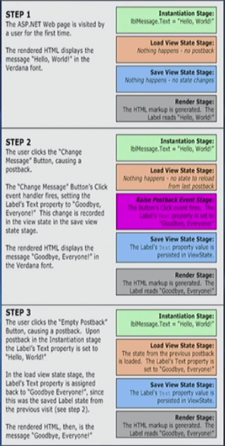

**View State – ViewState.aspx (Demo)**

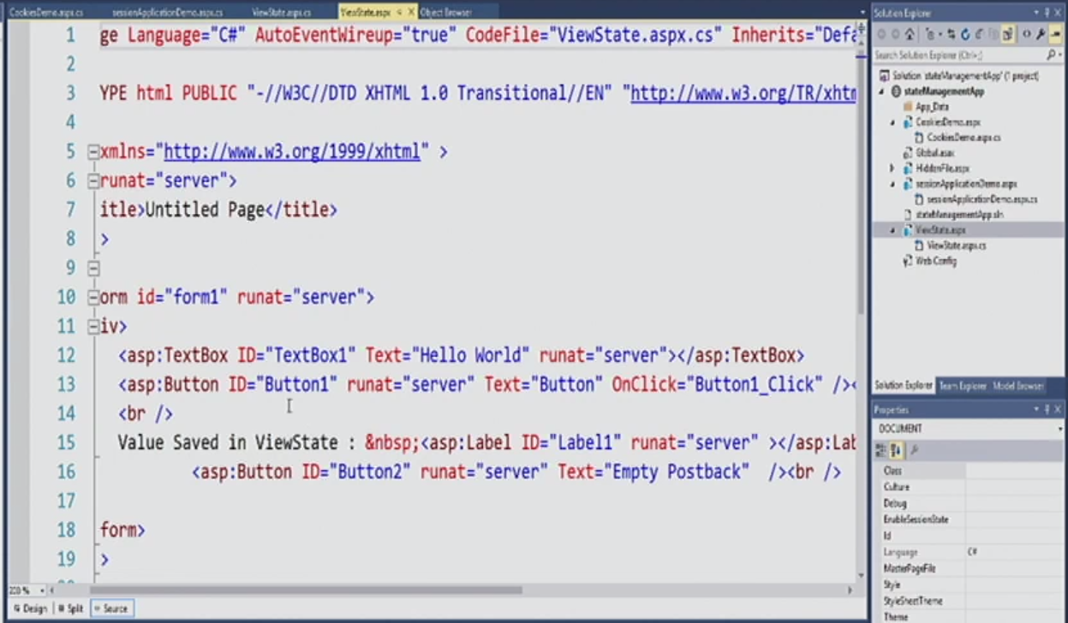

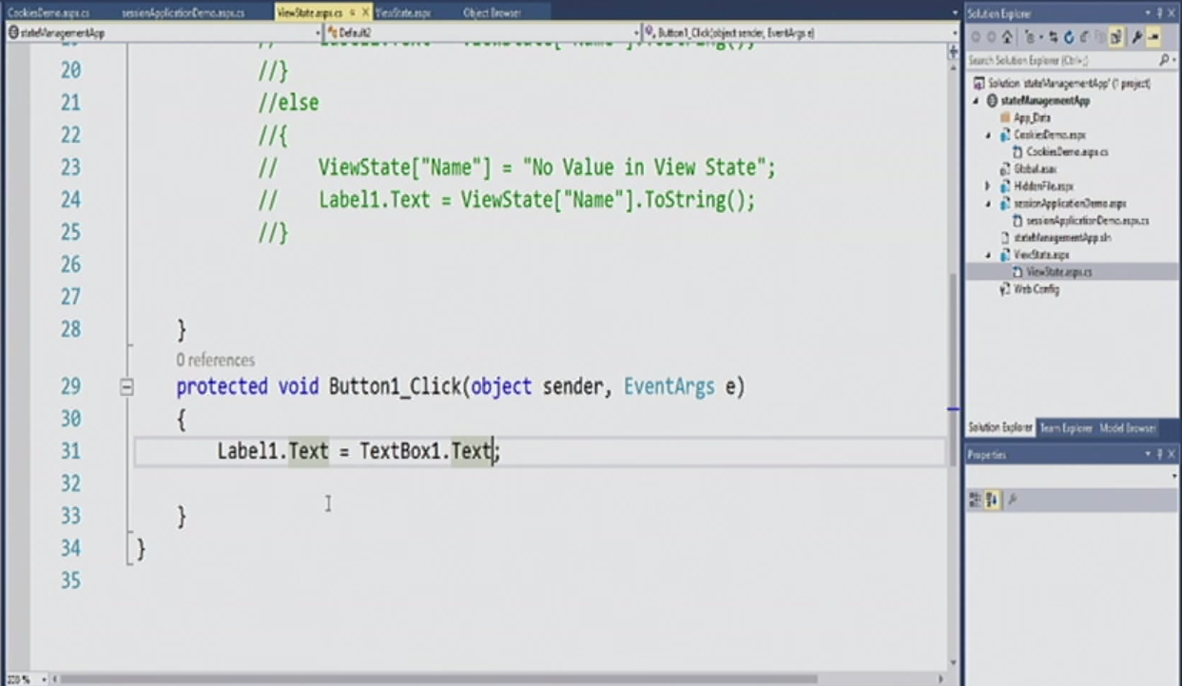

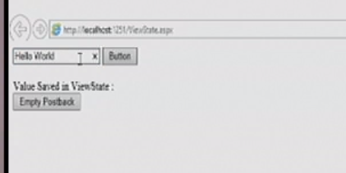

**Session State and Application State**

* Session State – Specific to a single user session
* A data repository available to all classes in an ASP.NET application
* Stored in memory on the server (faster)
* Applies to all users and sessions
* Useful place to store small amounts of often-used data that does not change from one user to another.

**Session State and Application State (Demo)**

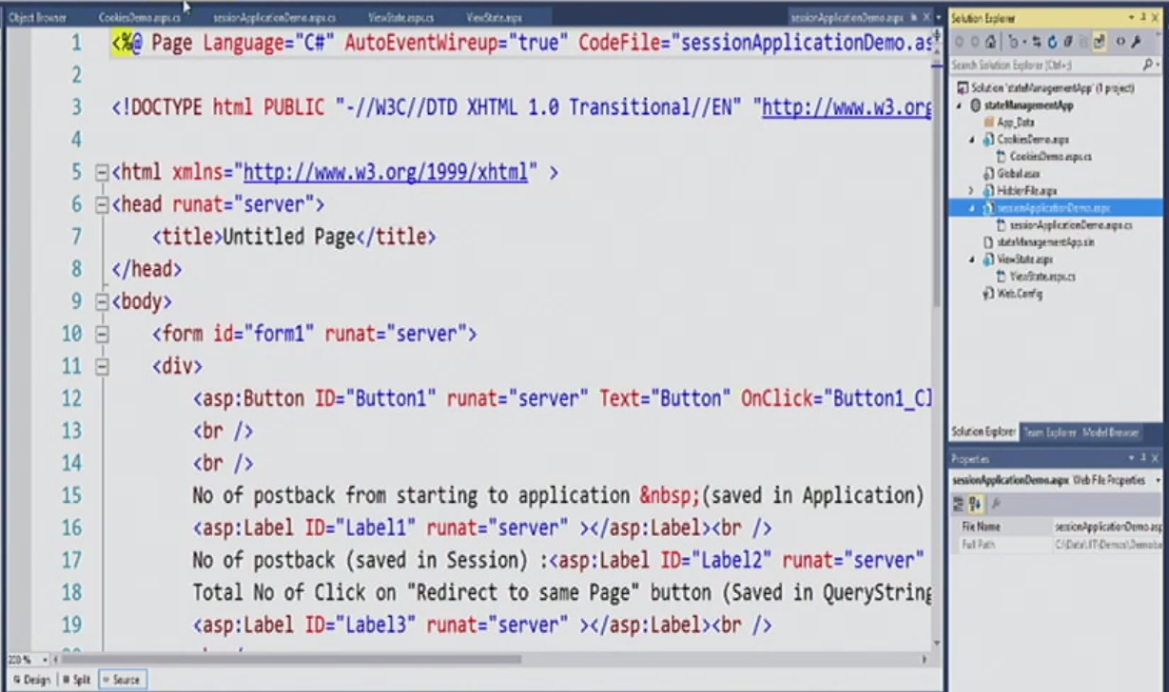

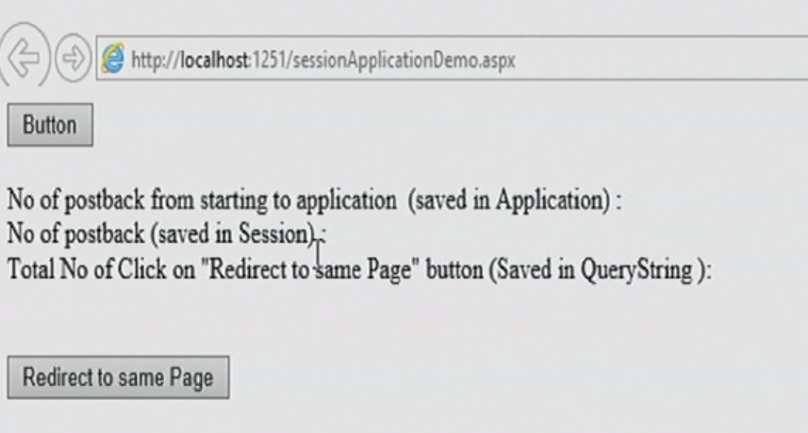

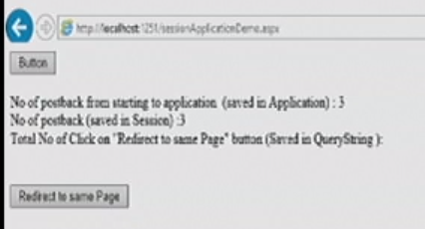

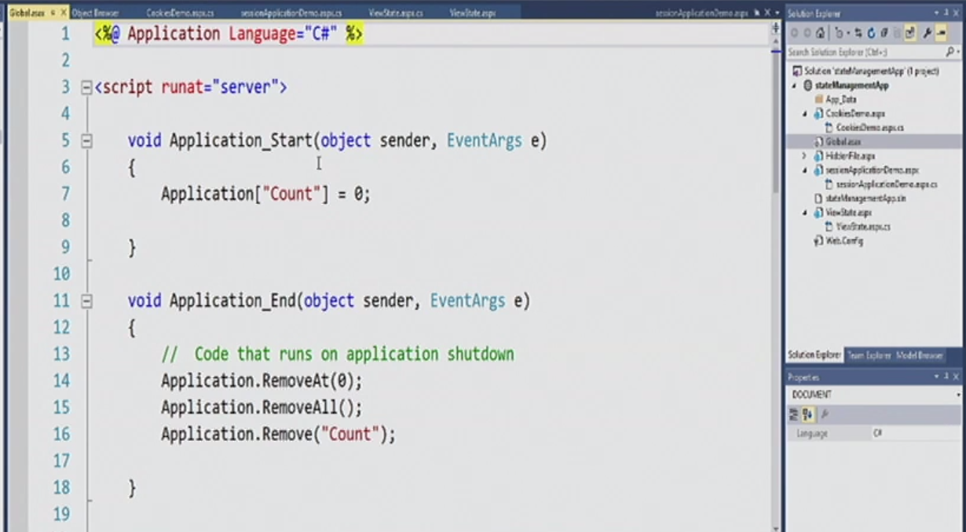

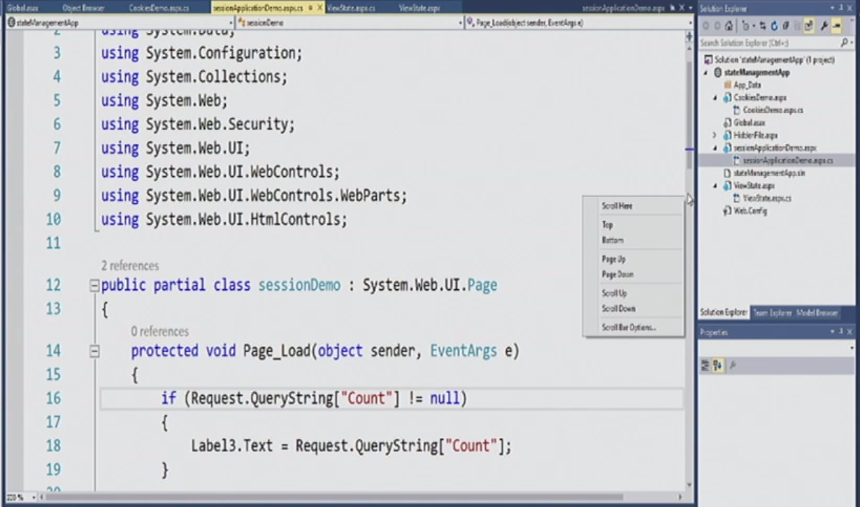

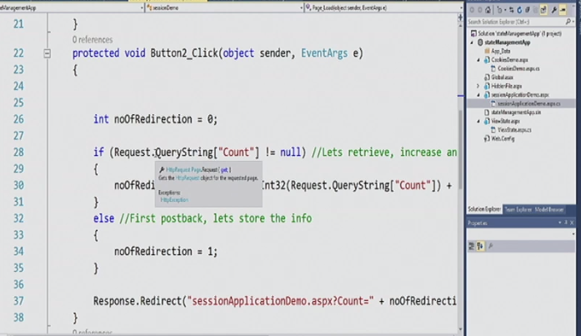

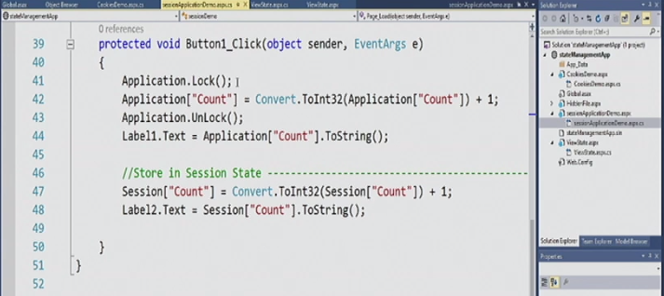

**What is the different with cookies and application state?**

Cookies: client

Application state: server

**Cookies**

* A small bit of text that accompanies requests and pages as they go between the Web server and browser.
* Contains information the Web application can read whenever the user visits the site
* Associate with a web site
* A user requests a page from a site
* Application sends a cookie with the page
* User’s browser gets the page with the cookie that is stored in a folder on the user’s hard disk.
* When the user requests a page from your site again, the browser sends the cookie.
* Used to helping the Web site remember you
* Users can set their browser to refuse cookies
* Write a cookie using the page’s Response property
* Cookie Expiration Time
* C:\Documents and Settings\<user>\Cookies

**Cookies Demo**

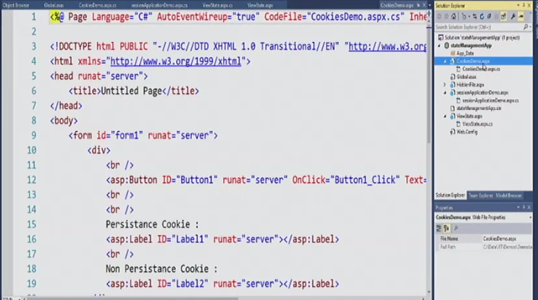

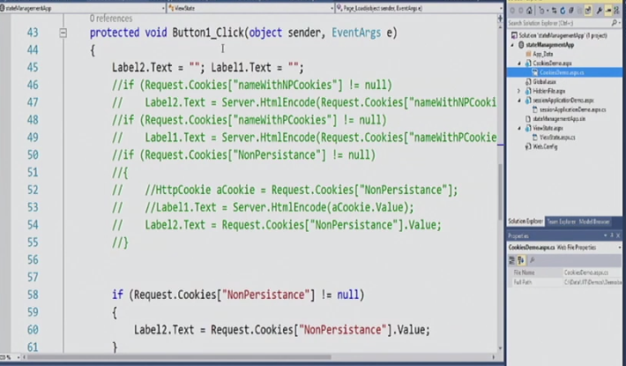

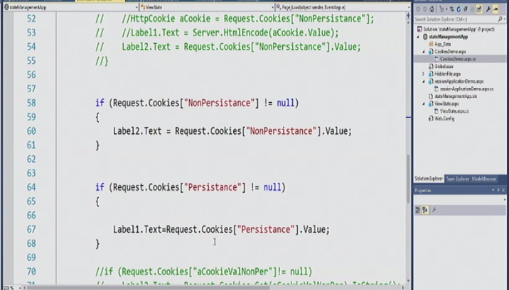

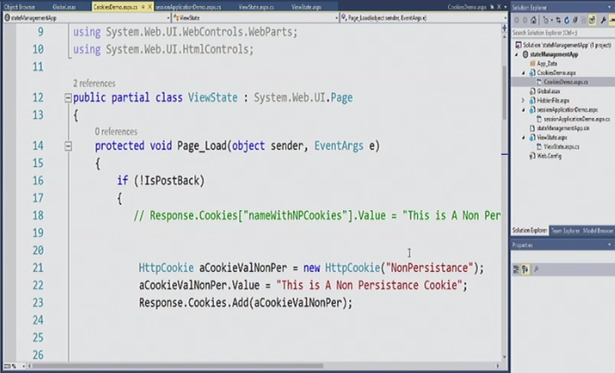

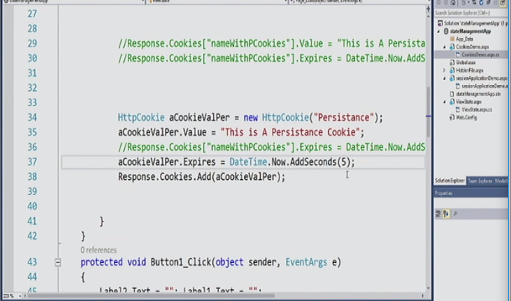

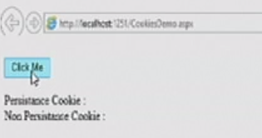

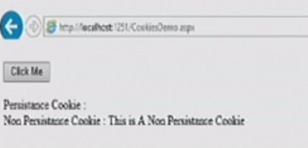

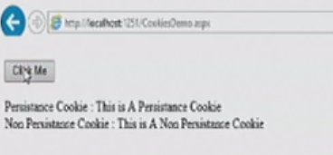

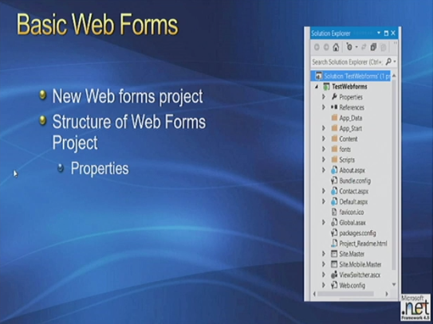

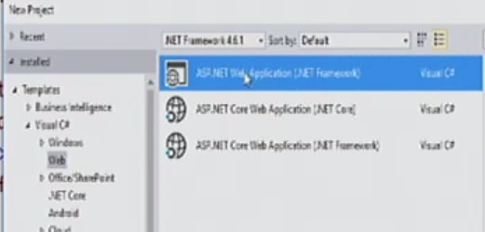

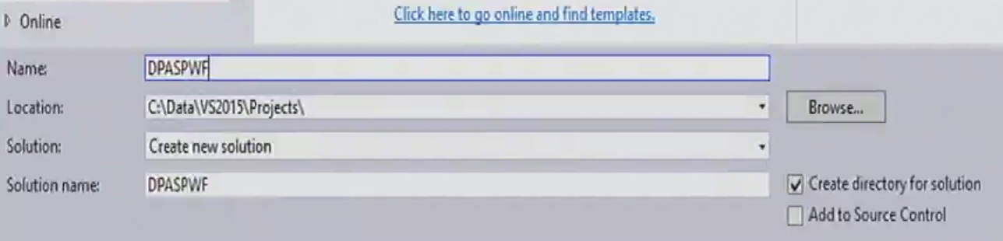

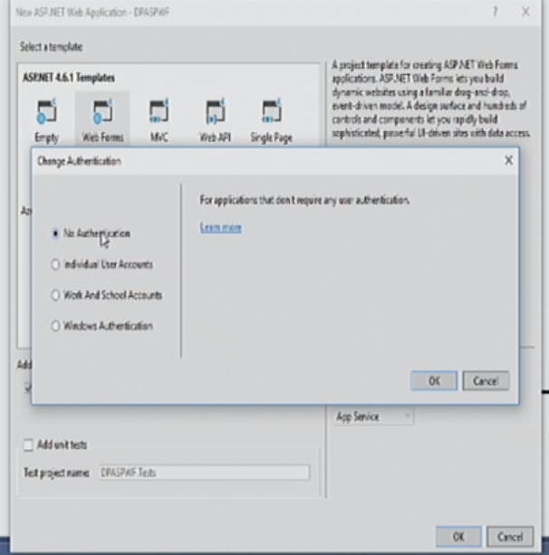 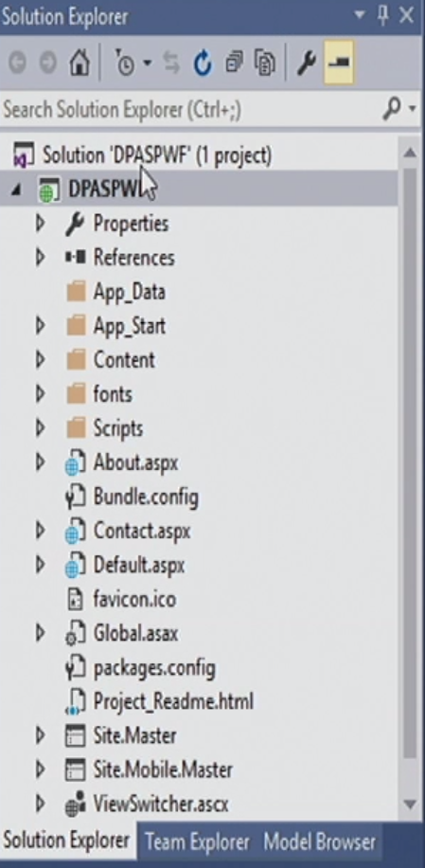

Right click the solution name to get the property and choose the differnet framework

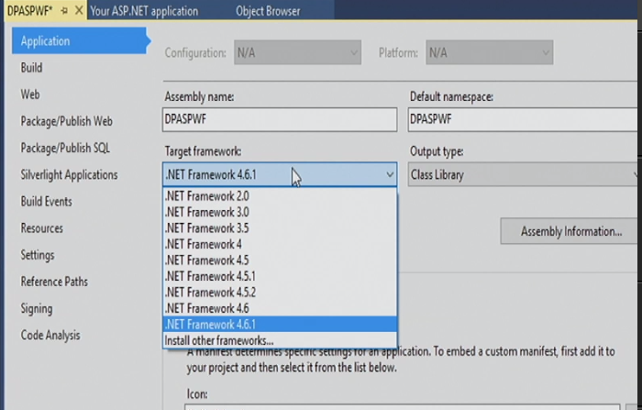

**What is the different between IIS Express and local IIS?**

IIS Express is web server; local IIS is local.

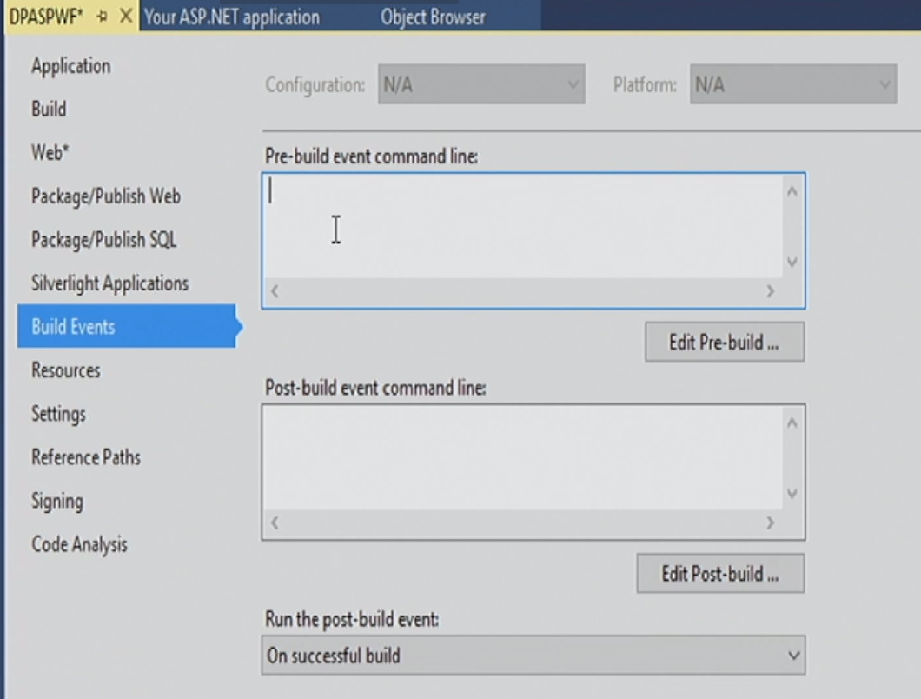

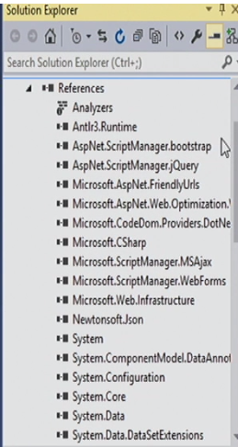 Reference is for assemberlings

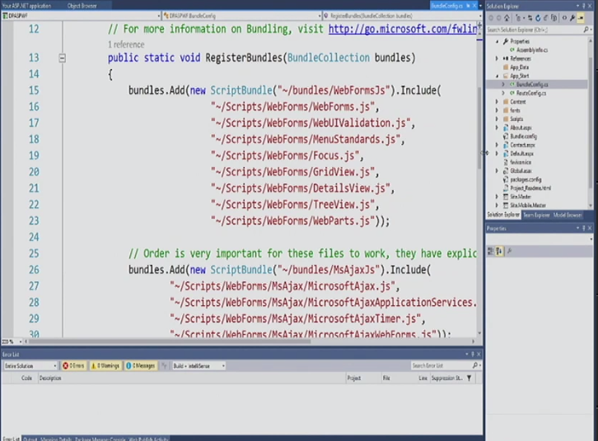

Bundling is JavaScript

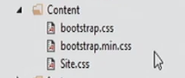Content is style

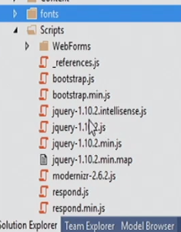 is default setting

Click the manage update.

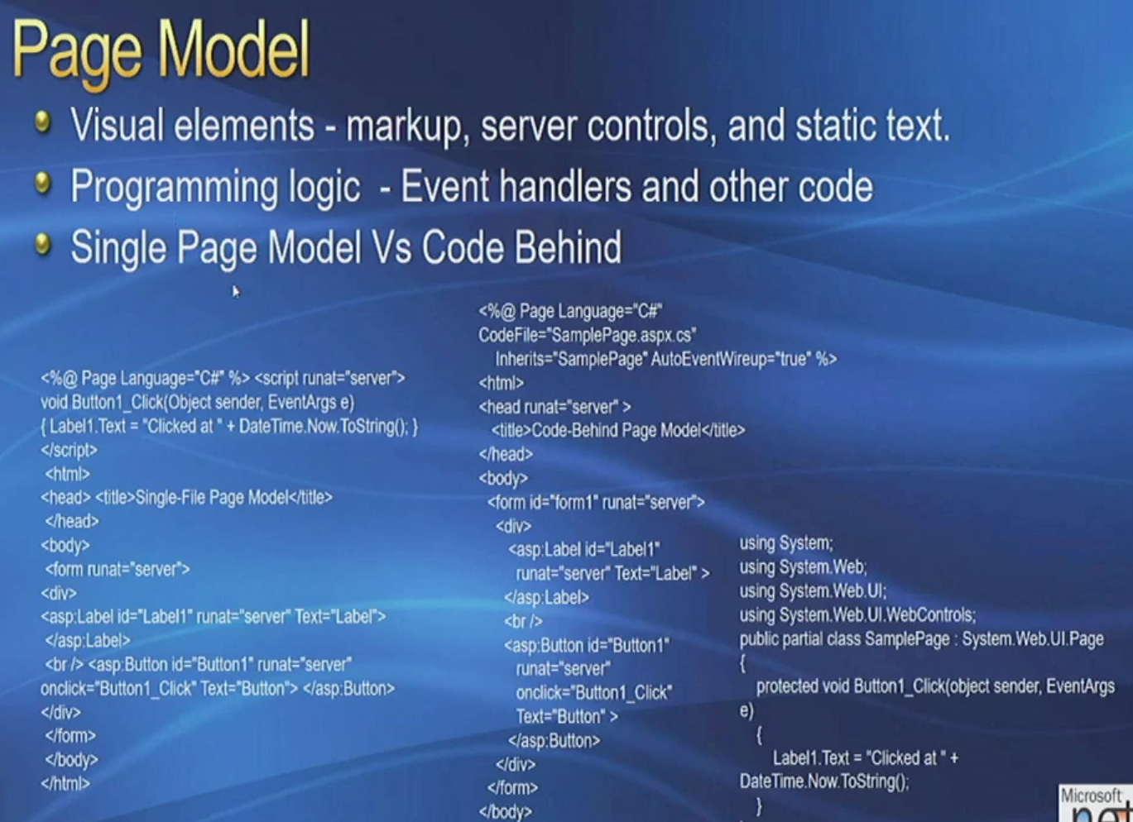

**Visual elements:**

* Static task:
* Html marker:
* Server control:

Single page model (not recommend)

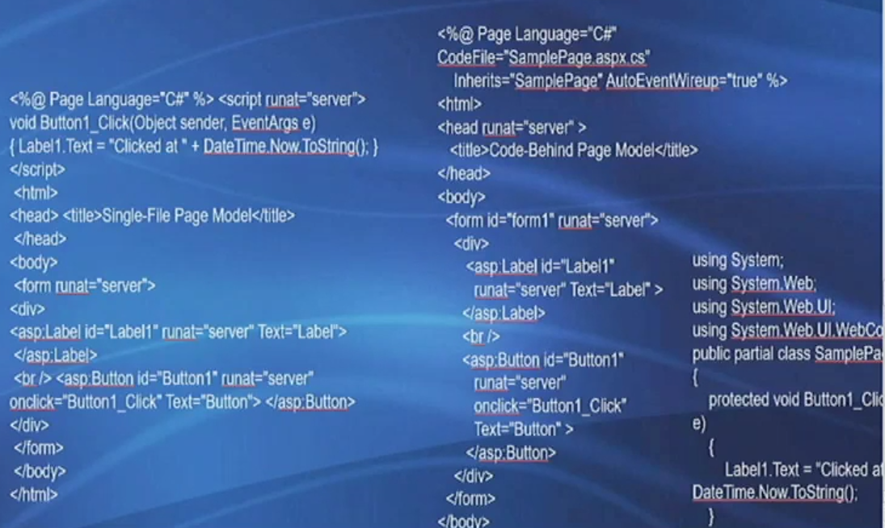

These two web pages’ different:

Left: single page site (write in everything in javascript in the page)

Right: separate the page and the code

**Rendering the page: Compiling classes that perform the tasks required to run the page**

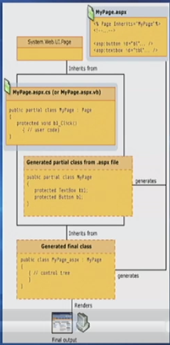

**AJAX Server Controls**

* Responsive to user actions like traditional client applications
* Reduce full-page refreshes and avoid page flicker.
* Enable cross-browser compatibility without writing client script.
* Perform AJAX-style client/server communication without writing client script.
* User controls and components from the ASP.NET AJAX Control Toolkit.
* Develop custom ASP.NET AJAX Control.

**AJAX Demo**

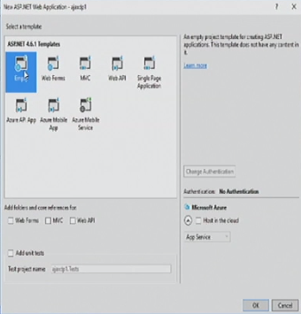

Add new web form

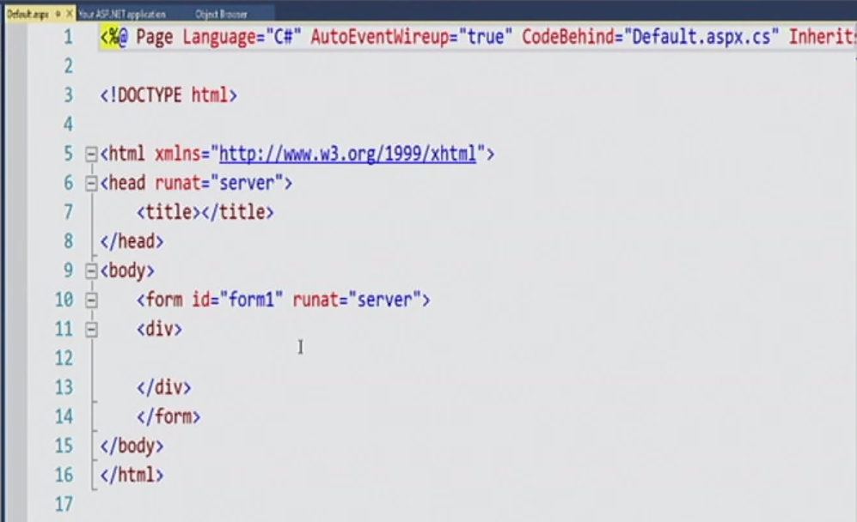

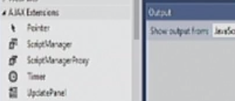

Go to design view:

ScriptManager (AJAX elements): add everything

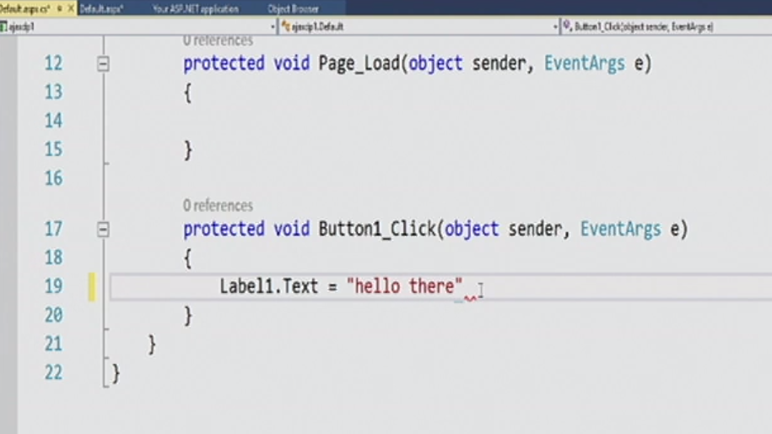

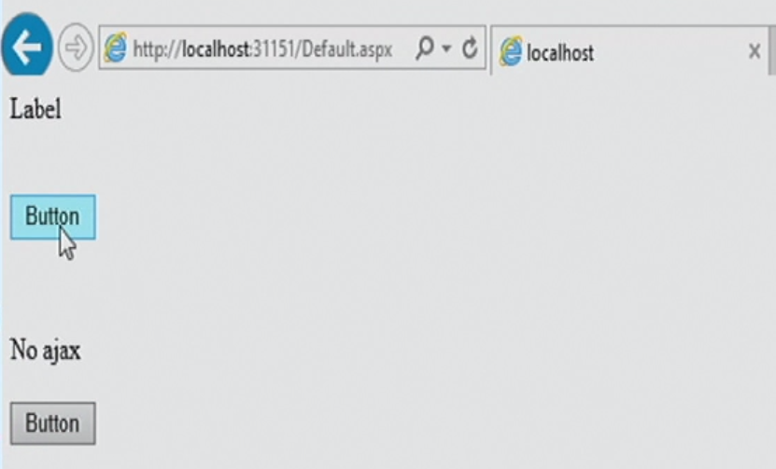

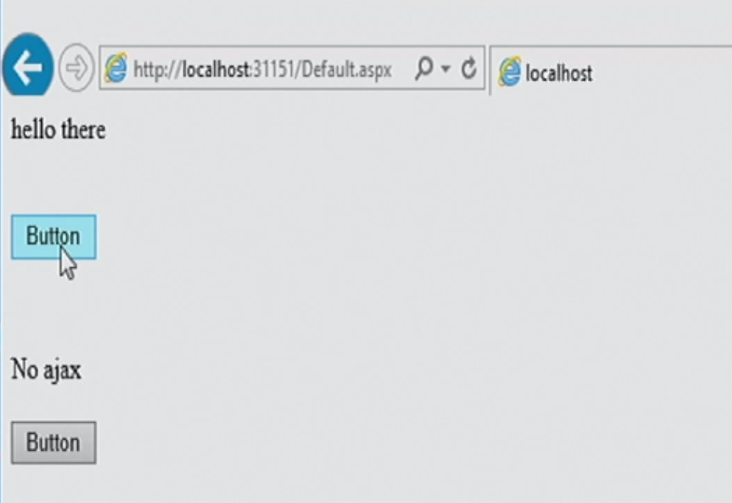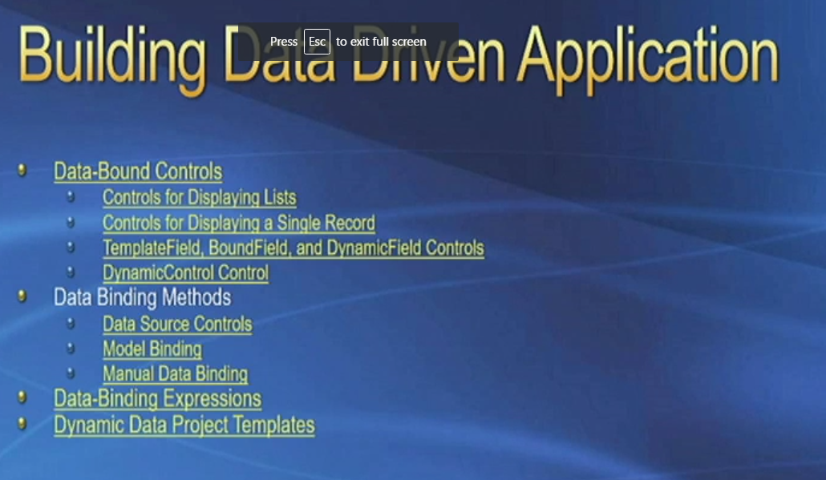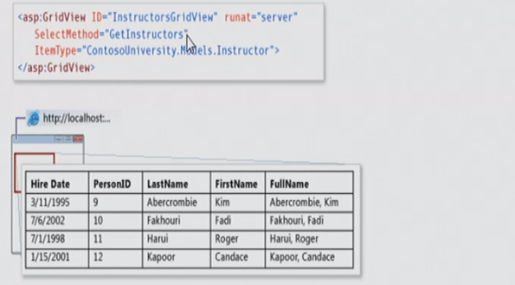

**Demo: create a new web form**

No authentication

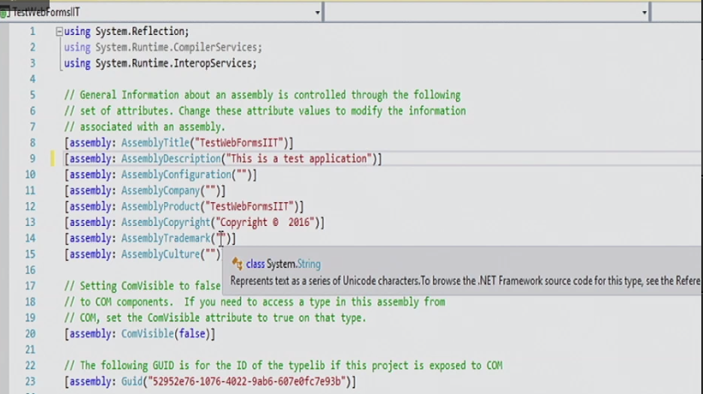

Tell you assemble

Reference default:

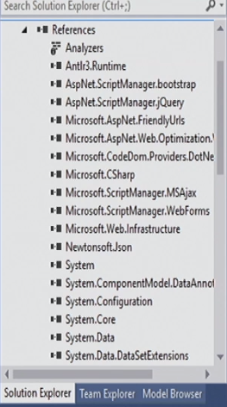

Folder of AppData: local data store here

Using JavaScript: every web browser can work

Disadvantage of JavaScript: complex and need load first

Bundlers function: combine all JavaScript together and form a single bundler

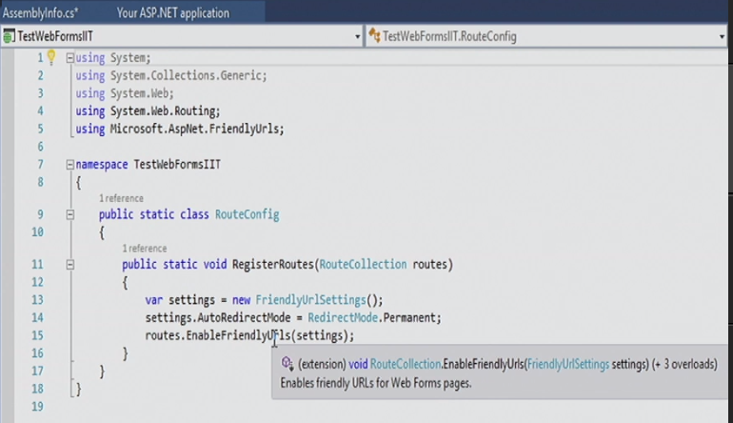

enableFriendlyUfls: MVC

bootstrap: can change (bootstrap.min.css) – the folder of script

contact.aspx and default.aspx are the templet which system create for you.

Site.Master: the templet for html of home page

Web.config: customer module and connect the stream

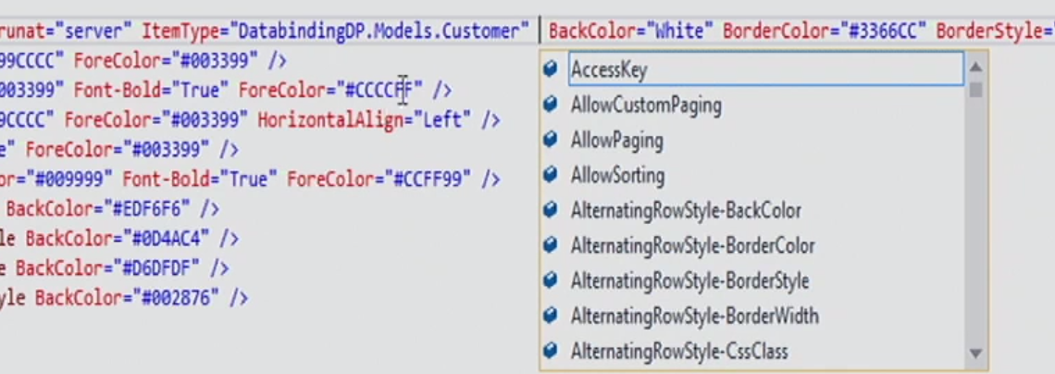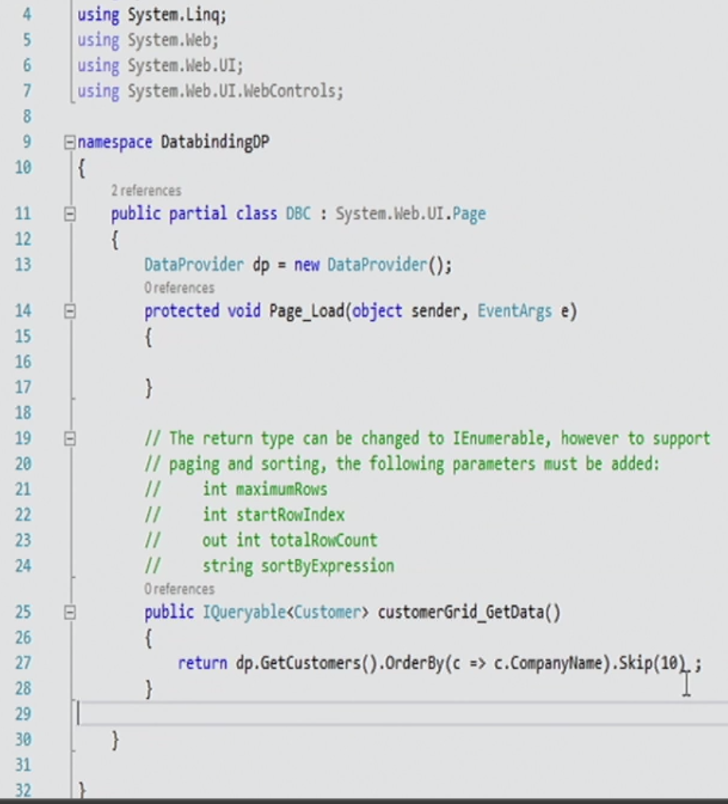

Site-map:

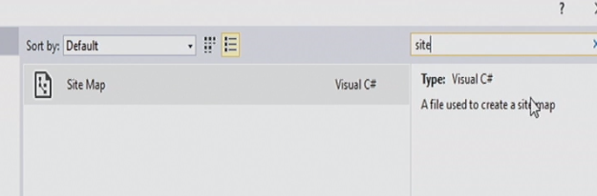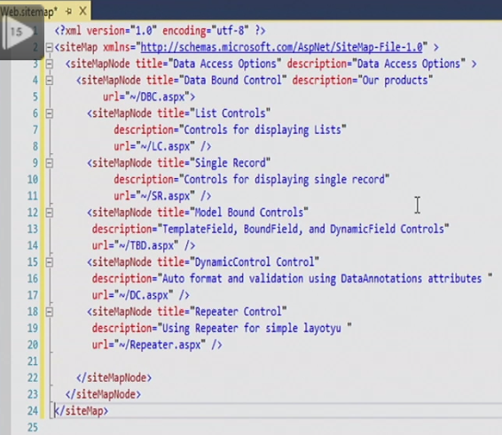

Step 1: add new item: data: entity data model

EF designer form database

You can change data mapping but not the database

Northwind database (go to website and downloand it, attach it.)

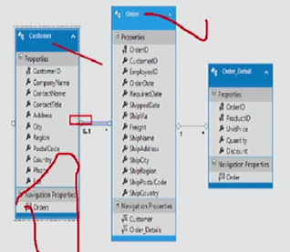

Build the entity

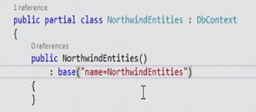

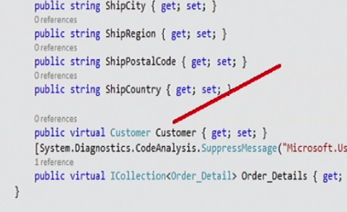

**Virtua**l means foreign key.

Gridview: (databinding)

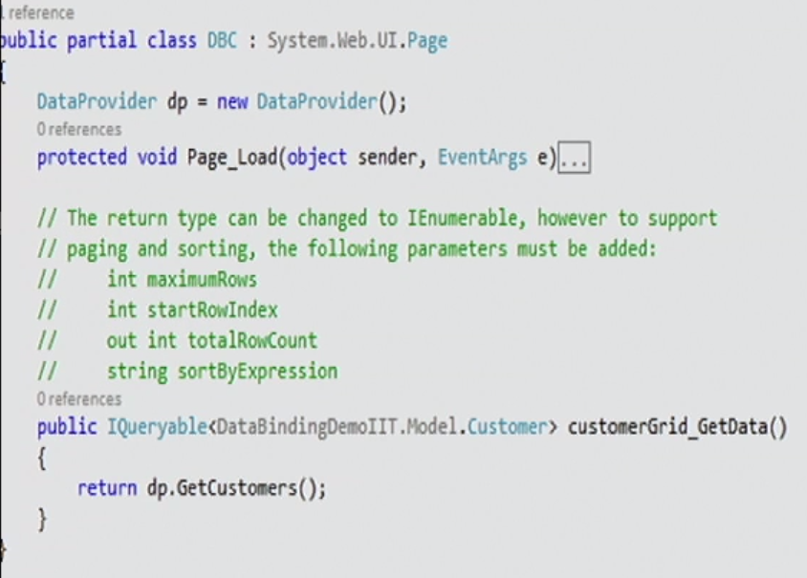

Listcontrol:

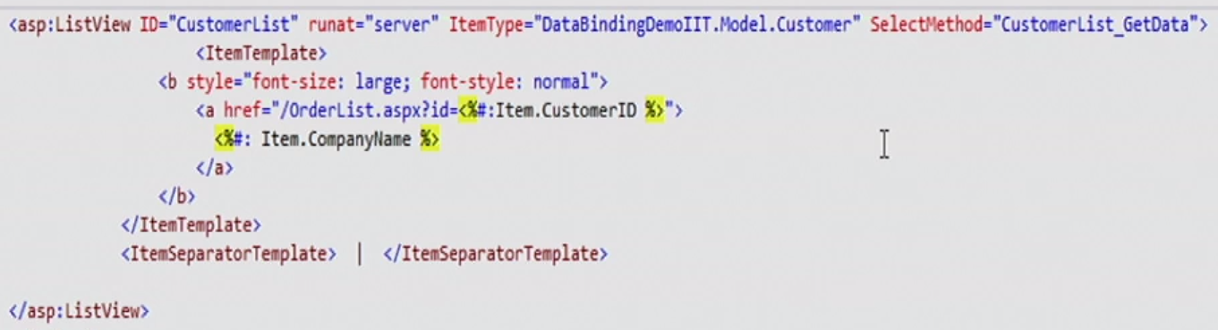

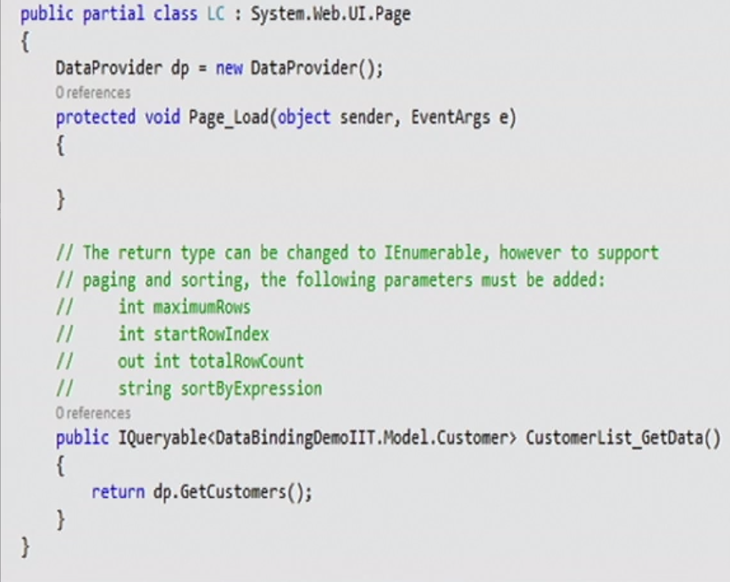

Weblink for listview:

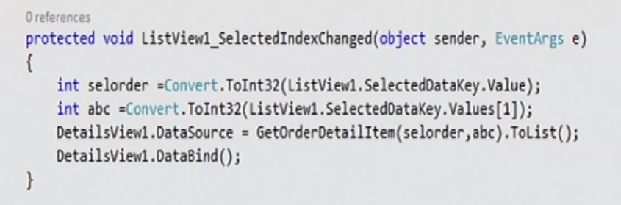

Repted control:

**Assignment Demo:**

Finial output: 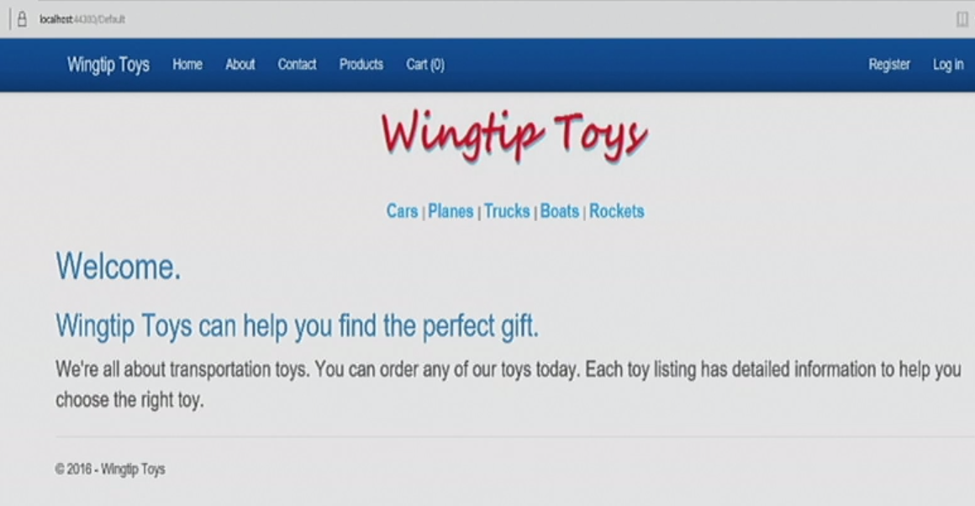

Loading page to sell some stuffs

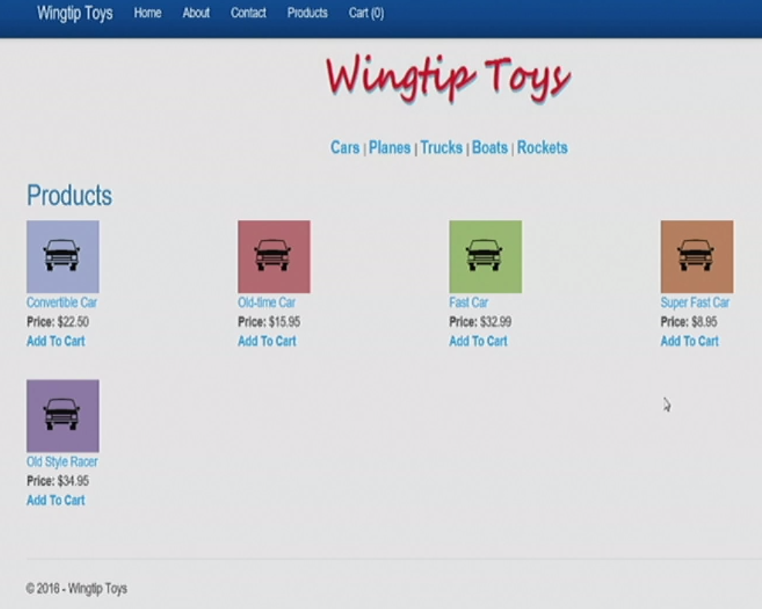

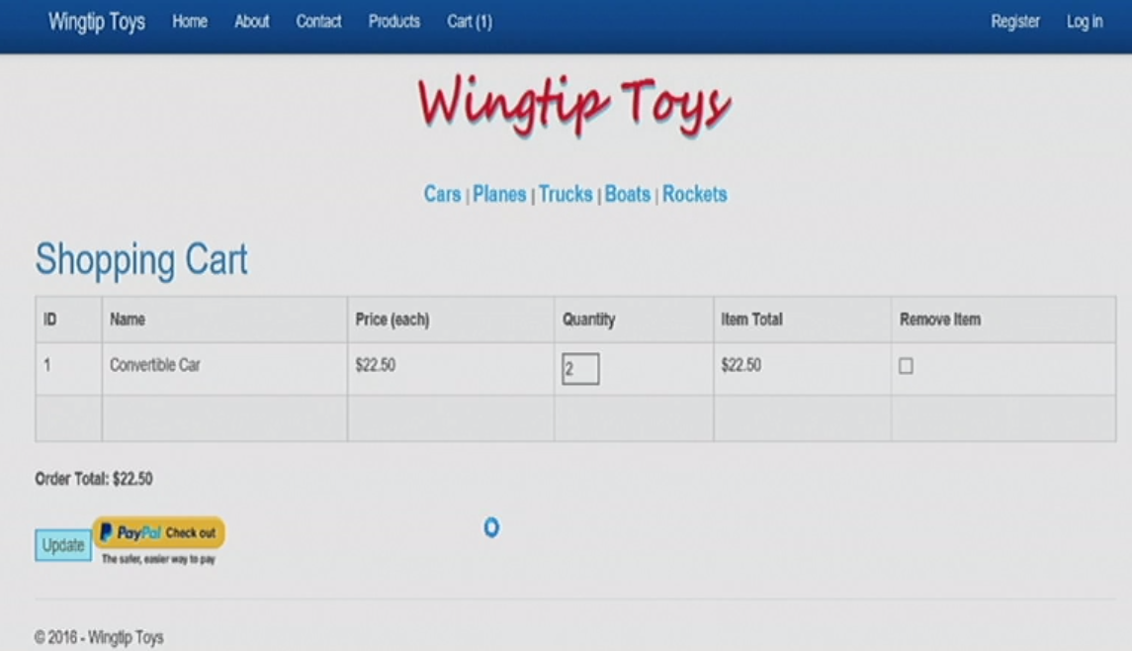

website:asp.net 🡪 learn 🡪 asp.net 🡪 web forms

<https://www.asp.net/web-forms/overview/getting-started/getting-started-with-aspnet-45-web-forms/introduction-and-overview>

steps:

1. Create a new project

Web form 🡪 not autificaiotn

1. Create a module folder
2. Create a new class for Product

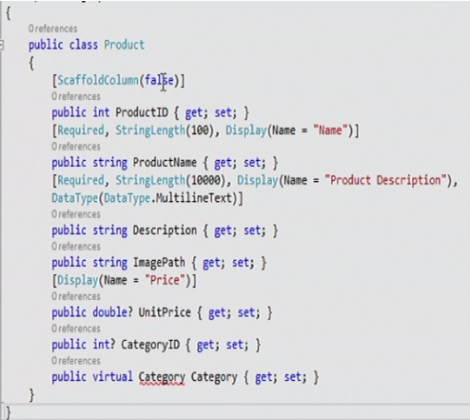

1. Create a new class for category
2. Create a new class for order

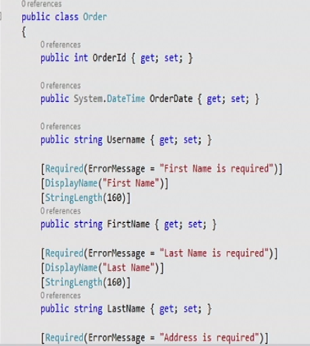

Virtual means lazy loading and this one has not virtual.

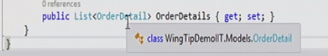

1. Create a class of cartItem.

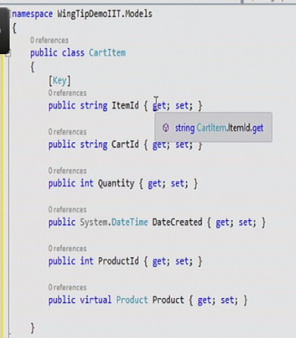

1. Create a class of productContext

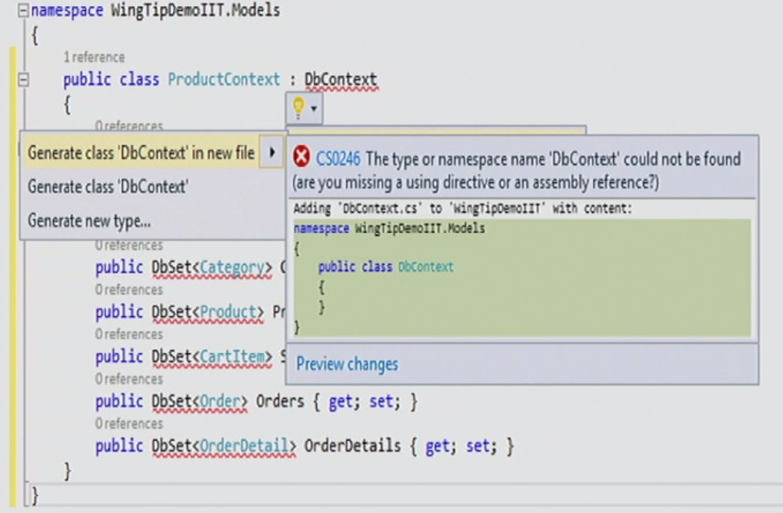

No reference because of no installing of entity framework.

Go to tool🡪packets and install

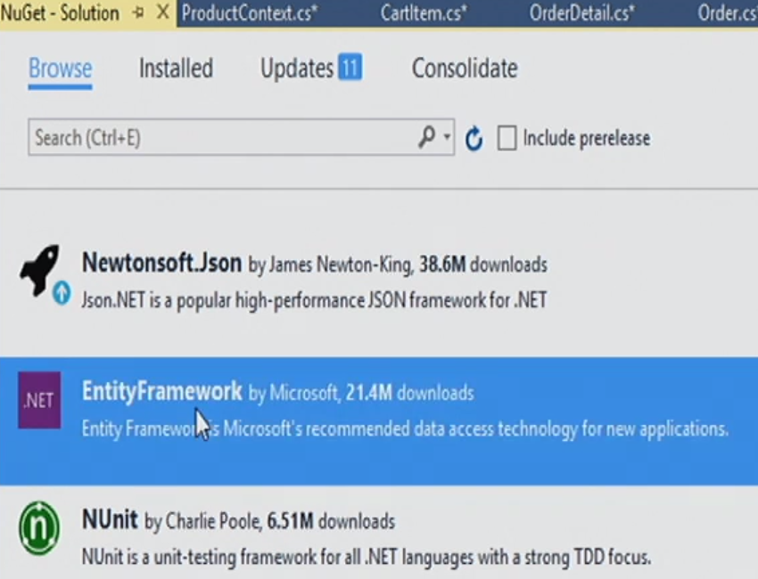

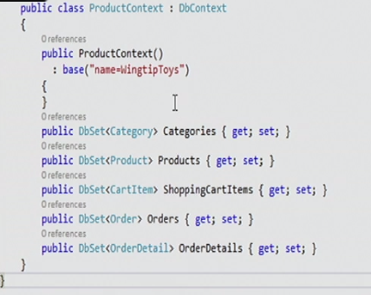

When add name= … means to do web config.

1. Do web config.



1. Add a class of ProductDatabaseInitializer (add all classes together)

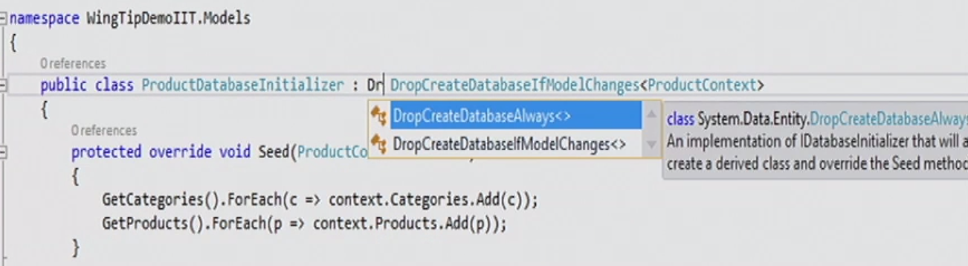

Only drop the database only the schema change

1. Globe.apx

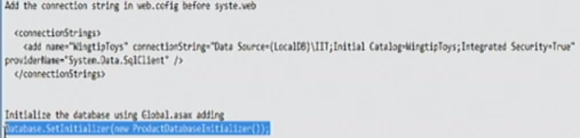

1. UI part 🡪 default.apx

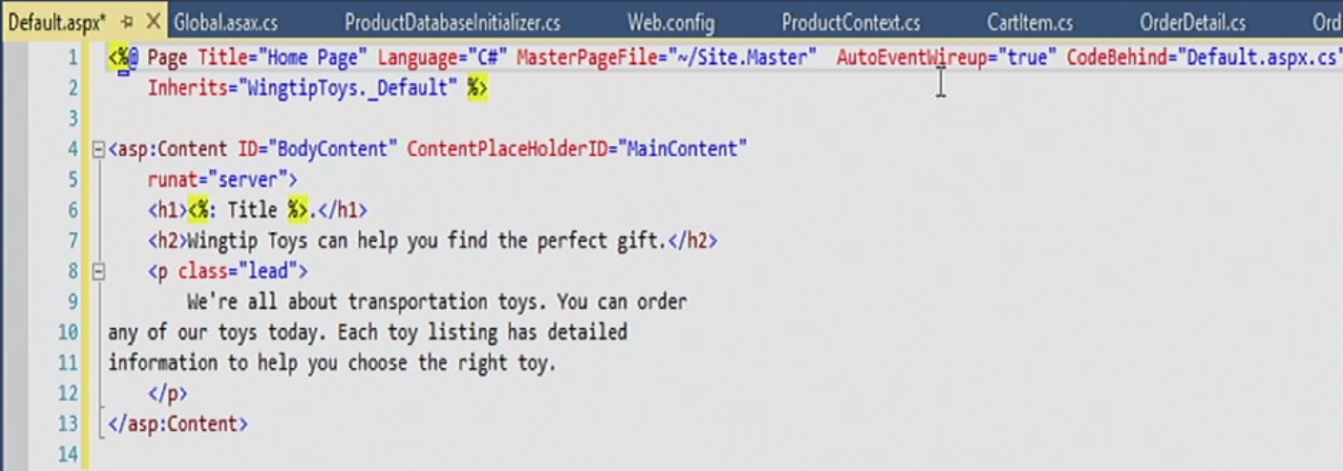

Inherits=”WingtipToys._Default” 🡪 WingtipToys is namespace should match the project name which is the project namespace.

1. In the master page:

Go to Site Master and change content: 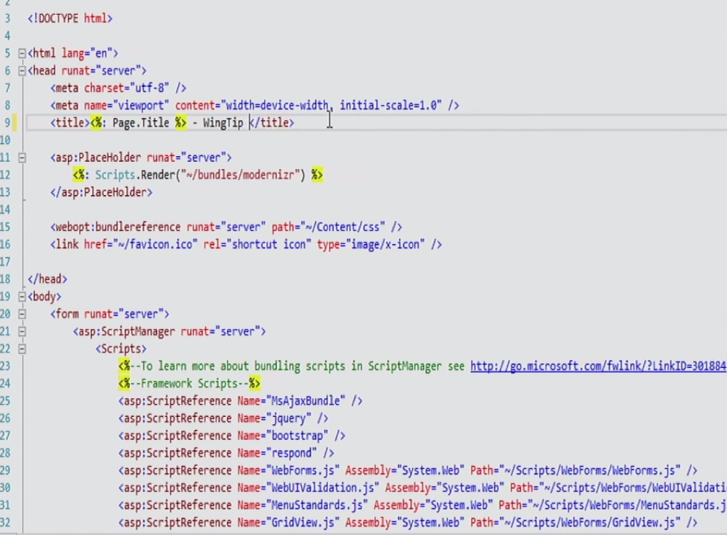

add navigation for product and productdetails. (two web form: web site)

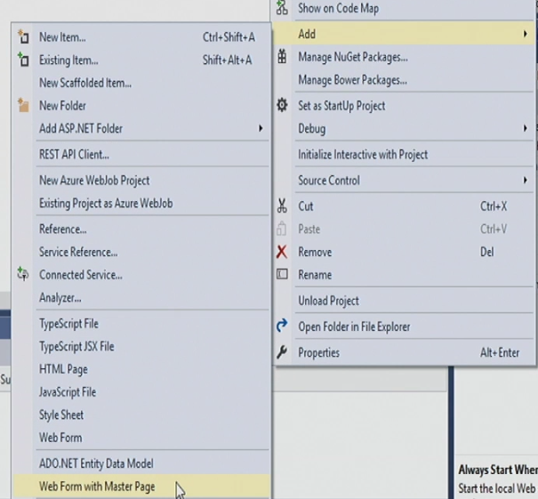

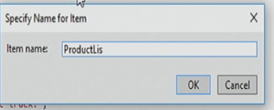

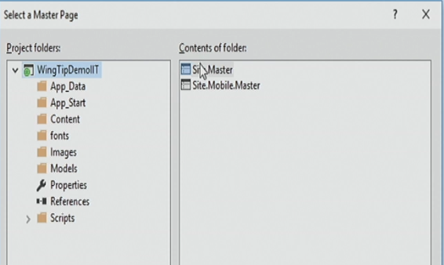

1. Add a litstview control in the masterpage, below the log image.

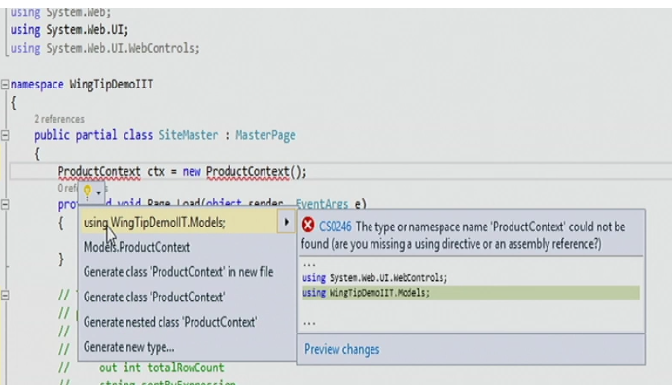

1. Upload to azure:

Resource group

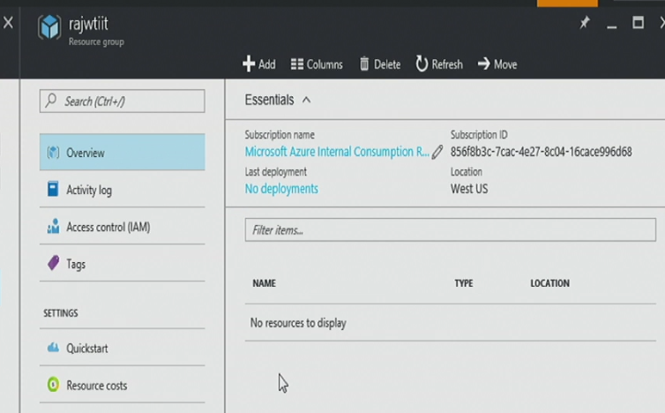

add a web app

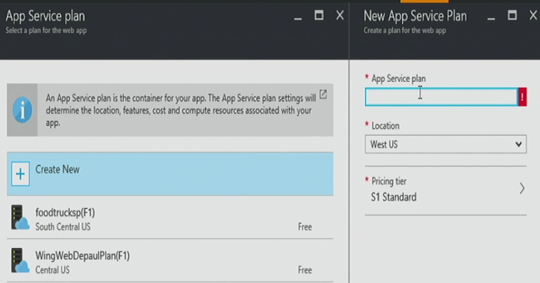

Should be the same location.

service plan: view all (free)

create a new sql server

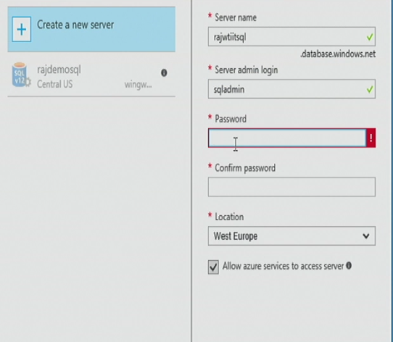

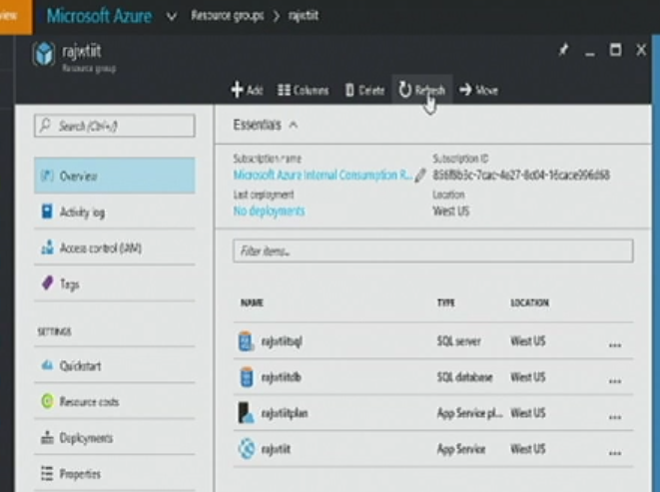

Enable migration: (console)

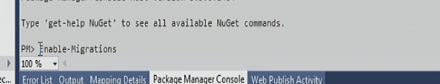

Go to azure and firewall setting, add a client ip.

